ROFIAT AJAGBE

rofiat.ayagbe@womentechsters.org

PRACTICAL ACTIVITY 5

**PRACTICAL ACTIITY 5**

**1. Carmax headquarters’ creation**

* Selected wnservercompanay.local
* Right clicked the blank page
* Then New and selected organization unit
* Then created the headquarters by imputingss the name

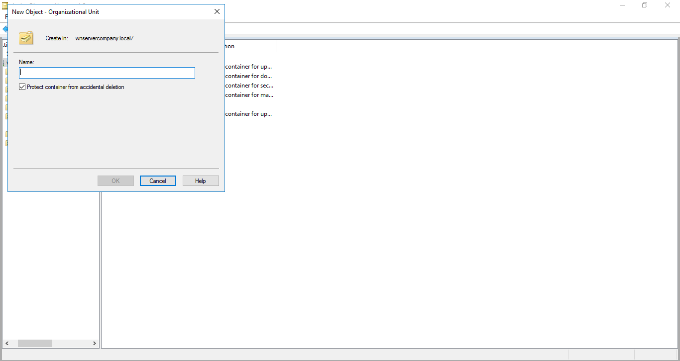

Then after creation the name is on the left bar highlighted

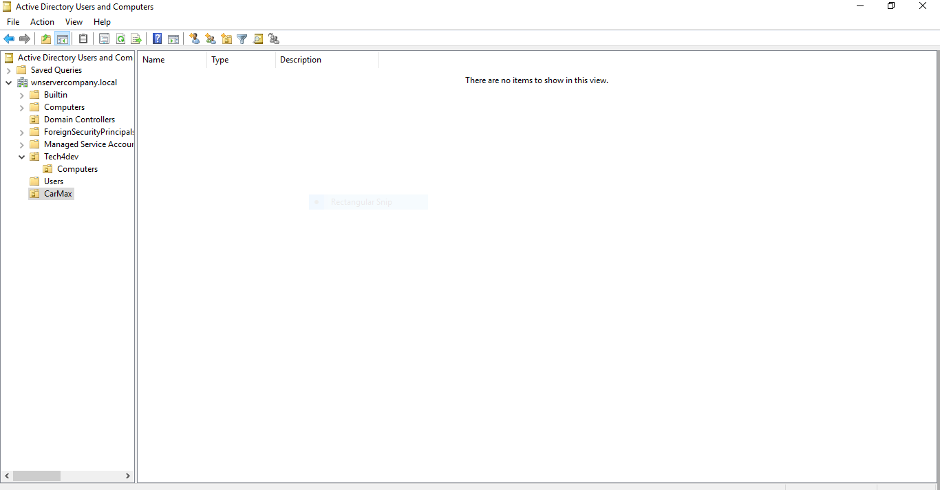

**Sales Location for Headquarters created**

* Selected the newly created CarMax headquarters
* Rightclicked then use the new button to select organization unit.
* Filled in the location name

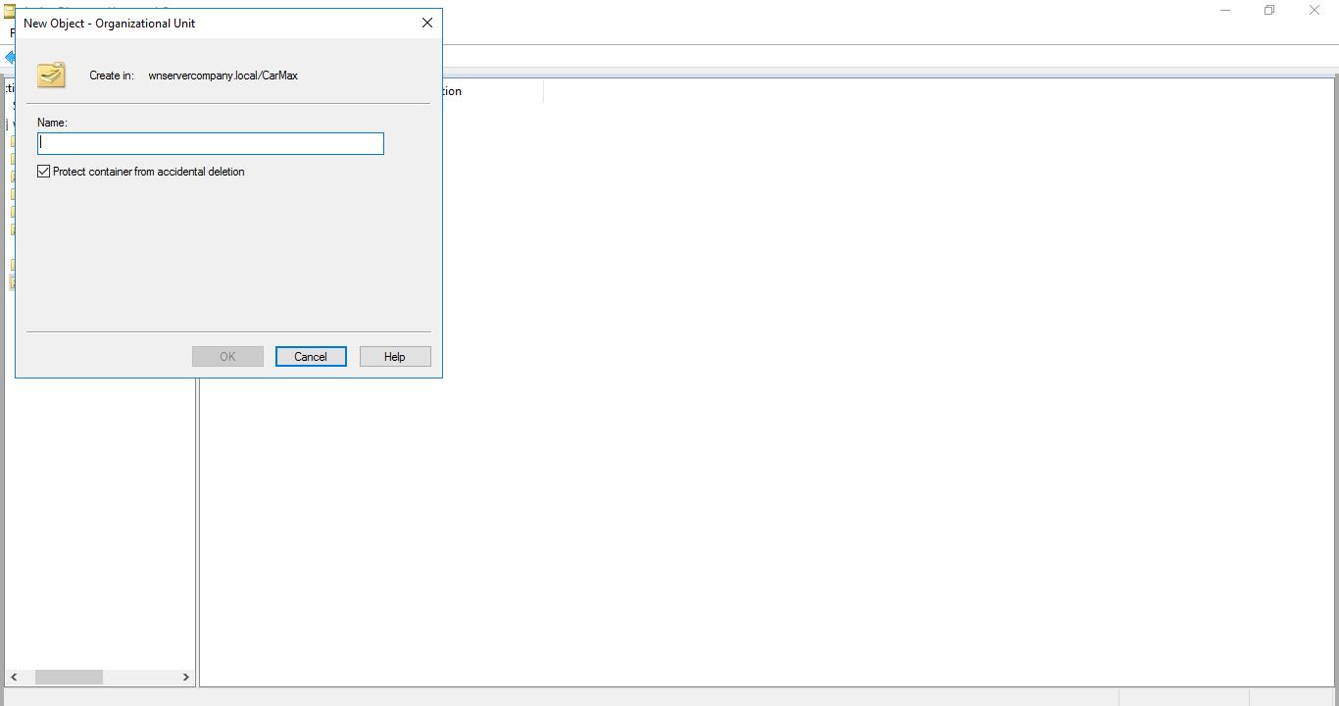

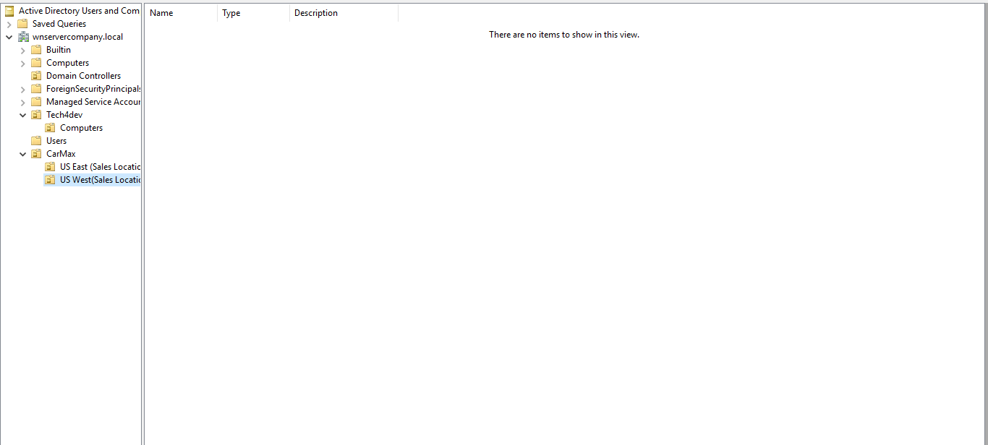

**Headquarters’ unit US East And West**

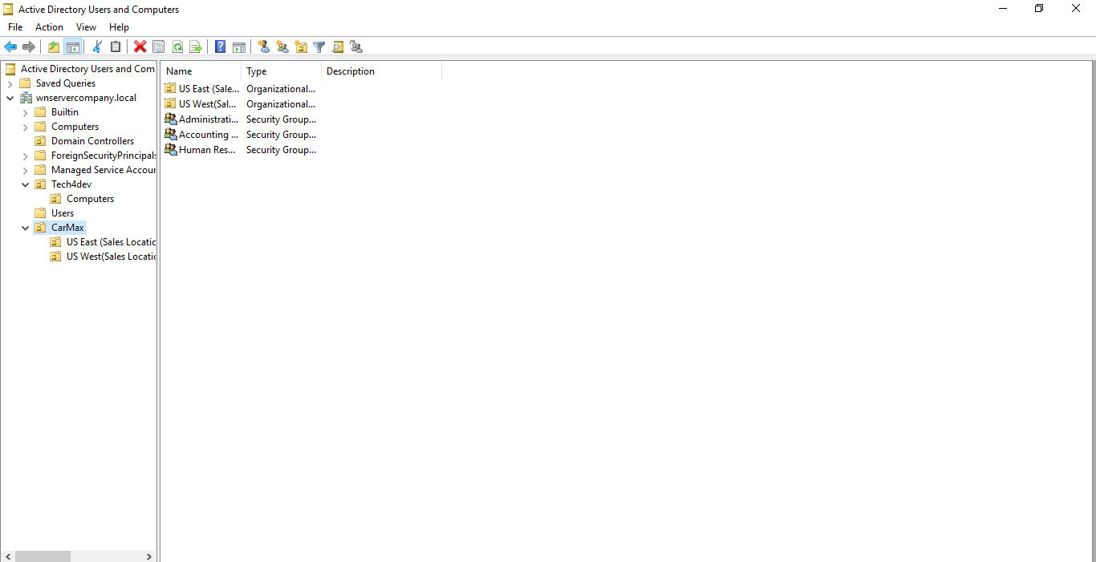

US East users creation

* Selected the sales location
* Rightclicked selected new from the dropdown
* Then new users
* Then filled user form page

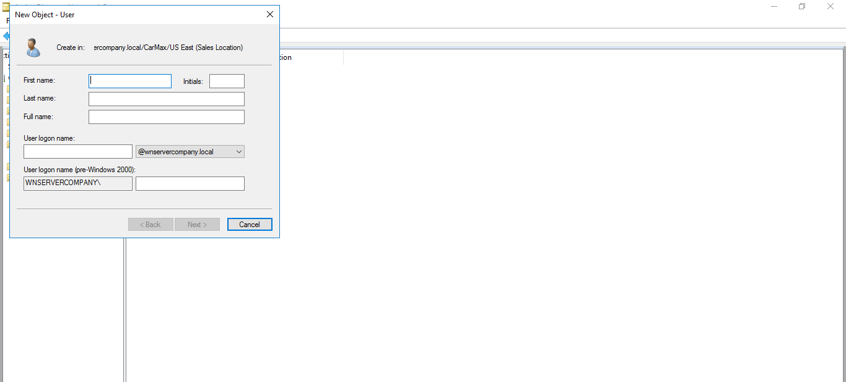

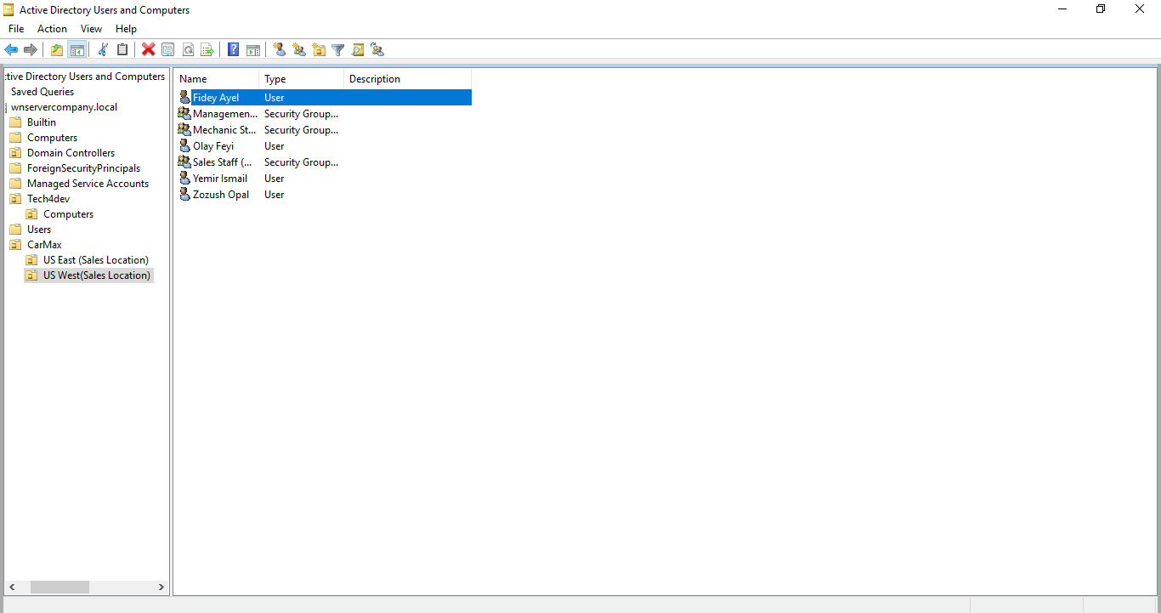

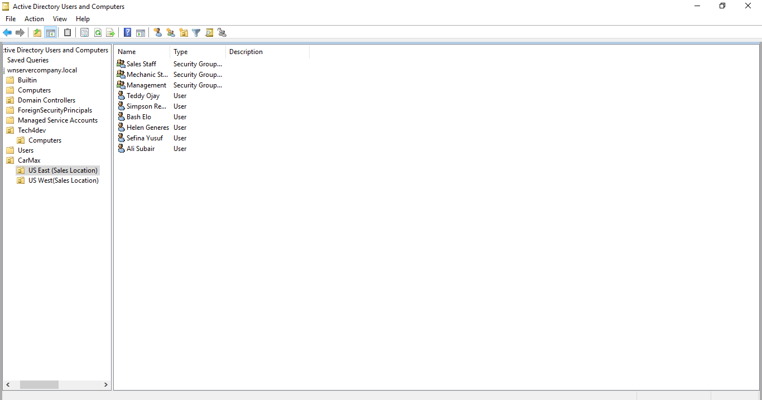

Sales Location Staff units created for (US East)

* Selected the desired location
* Rightclicked selected new
* Then picked organizational unit
* Input the Location Staff unit

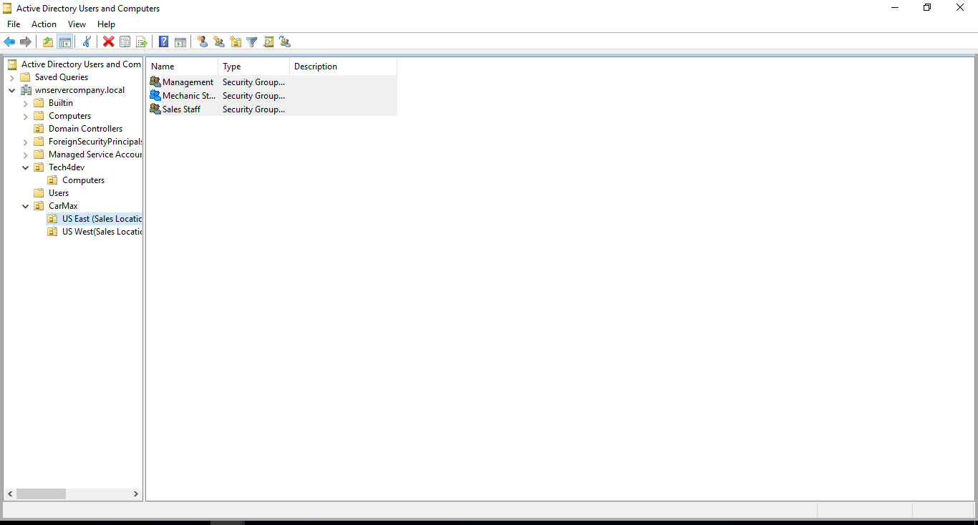

Sales Location Staff units created for (US West)

* Selected the desired location
* Rightclicked selected new
* Then picked organizational unit.
* Entered the new name of the location staff unit

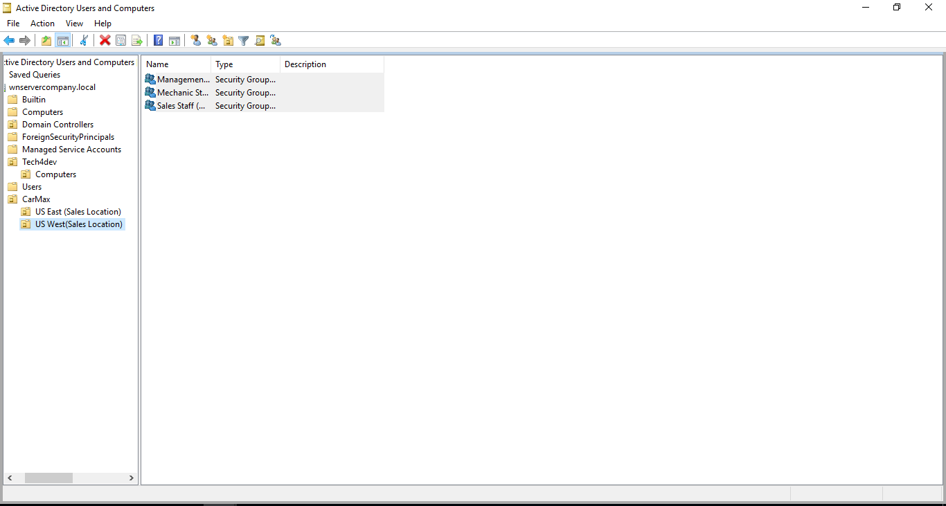

**2 (i) US East dummy Users created**

* Selected the location US East.
* Clicked on the blank page.
* Selected new user added name, logs on id and password.

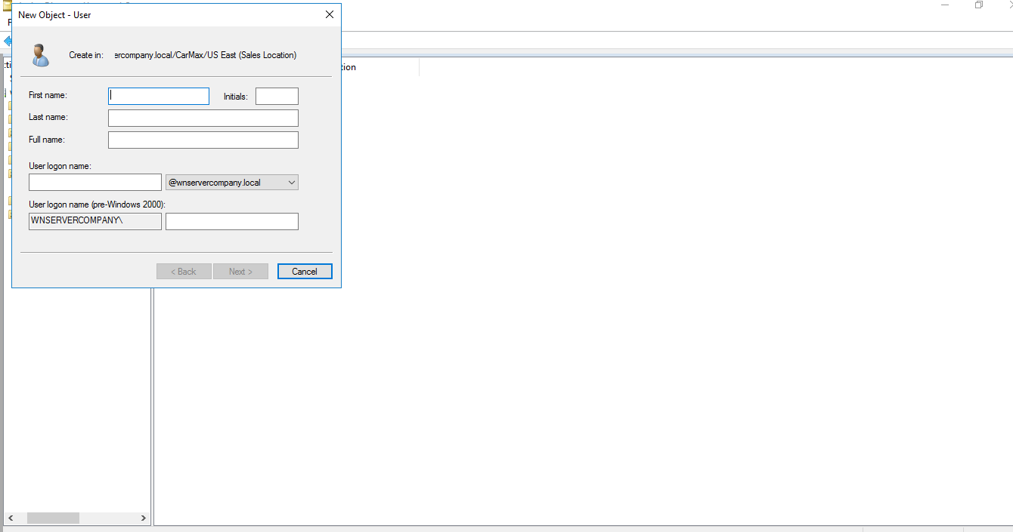



**2(ii)US west dummy user’s creation steps**

* Selected the location US West
* Clicked on the blank page
* Selected new user added name, logs on id and password

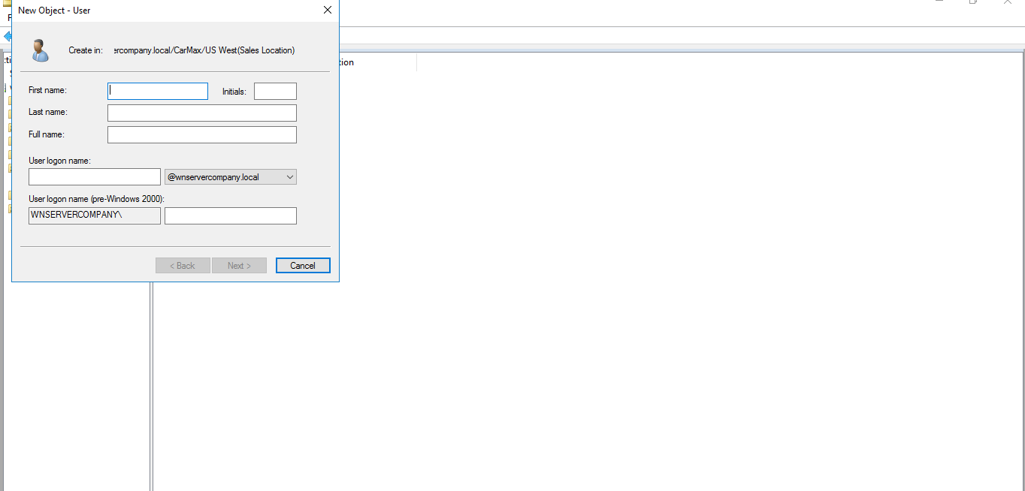

* Selected the location US West
* Clicked on the blank page
* Selected new user added name, logs on id and password

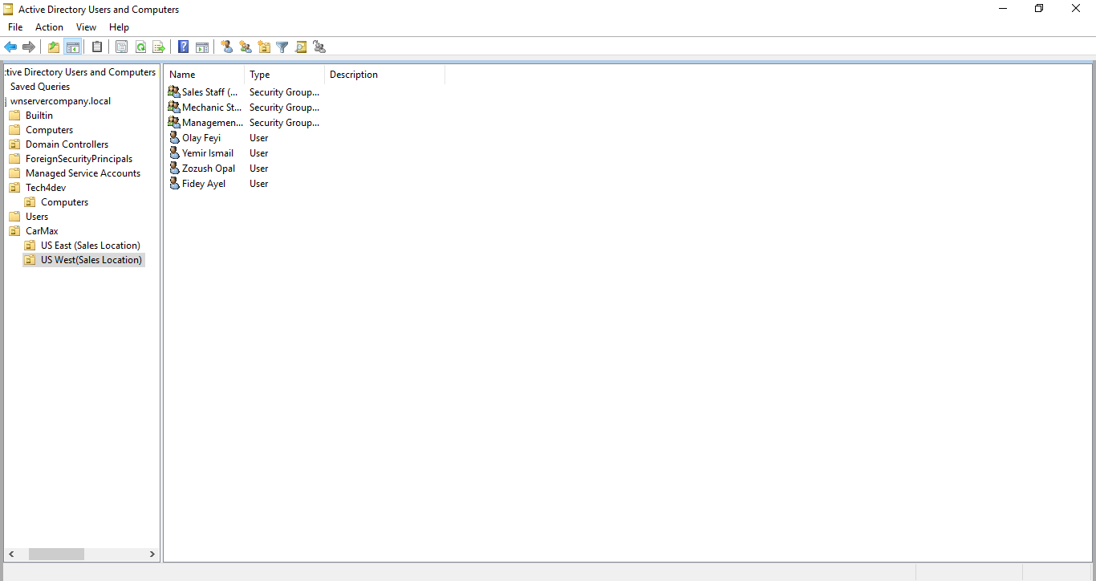

2.To move or transitioned selected the Administrative dept

The sales member Simpson before been transferred to Administrative dept

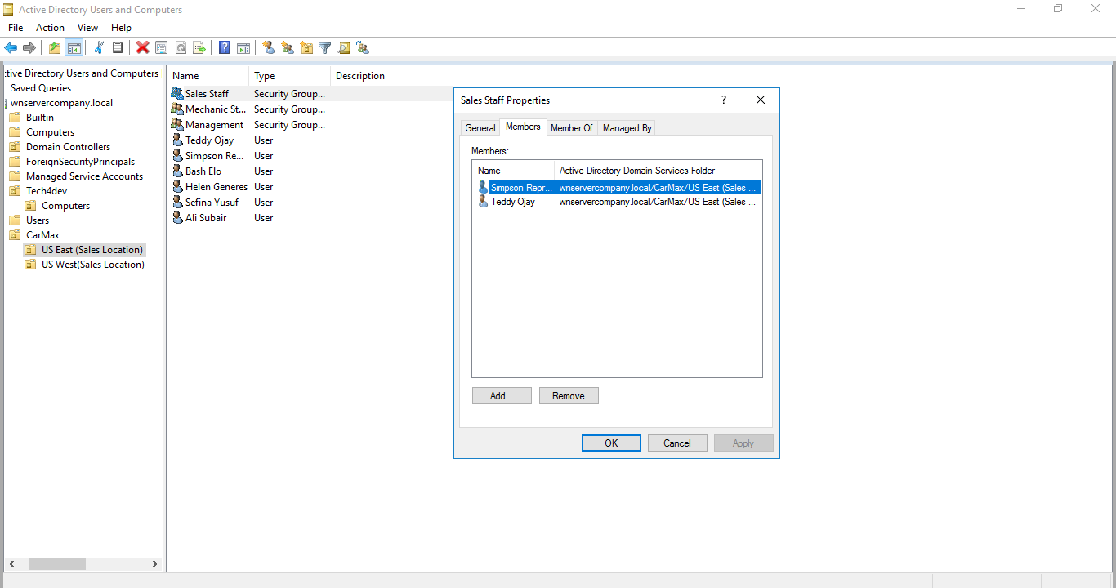

1. I opened properties of the administrative unit-then selected members.
2. Searched on the user’s name of Simpson which was suggested by the prompt then transitioned to the desired unit.

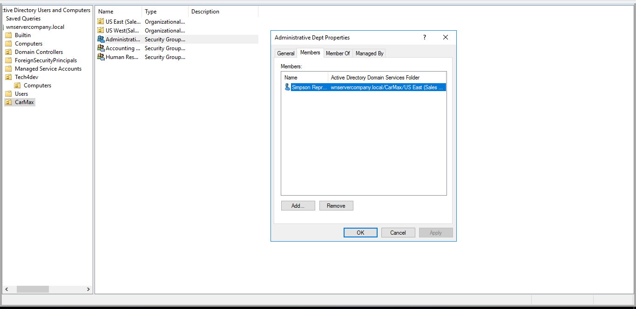

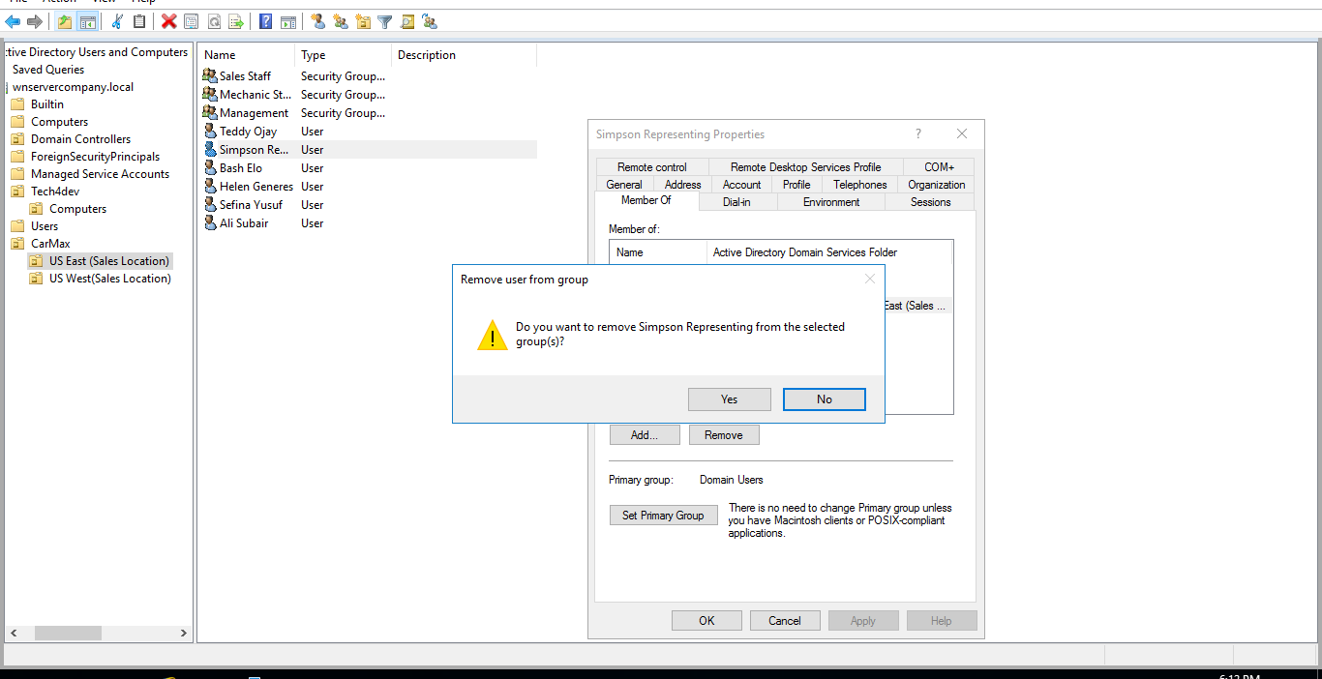

3.Last screenshot is to confirm he is no longer in the sales staff unit and successfully transitioned to the Administrative dept.

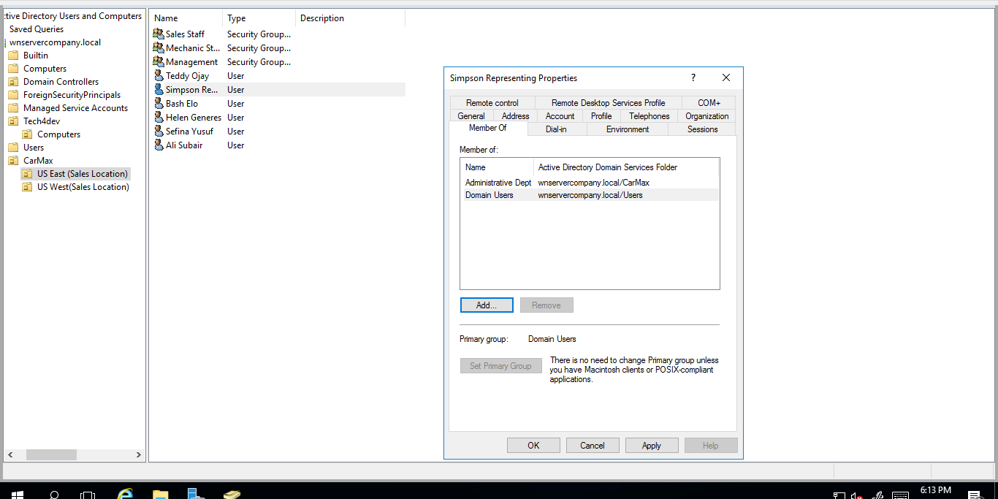

4.Changed Administrative department as primary account to be able to remove him from domain user

4.Deactivate account for Mechanic staff on leave

* I confirmed Elo is in the mechanic group from the properties tab
* Then located the users OU “Organizational Unit”.
* Right-clicked the mentioned user that i wanted to disable, I chose user called Elo
* Clicked on “Disable Account” and then a message appeared that the user is disabled.

